**SAVING AND LOADING DATA**

**LAB # 05**



**CSE402L Digital Signal Processing Lab**

Submitted by: **Shah Raza**

Registration No: **18PWCSE1658**

Class Section: **B**

“On my honor, as a student of University of Engineering and Technology, I have neither given nor received unauthorized assistance on this academic work.”

Student Signature: ______________

Submitted to: **Engr. Faiz Ullah**

Monday, January 11th, 2021

**Department of Computer Systems Engineering**

**University of Engineering and Technology, Peshawar**

**Lab Objectives:**

Objectives of this lab are as follows:

* Learn saving and loading data in Visual DSP++ and MATLAB

**Practical:**

1. Generate a sinusoid of 10 kHz in MATLAB. Store the data in an ascii and *.mat file with the name sinedata.



1. Load the same file data in some variable and plot the data.



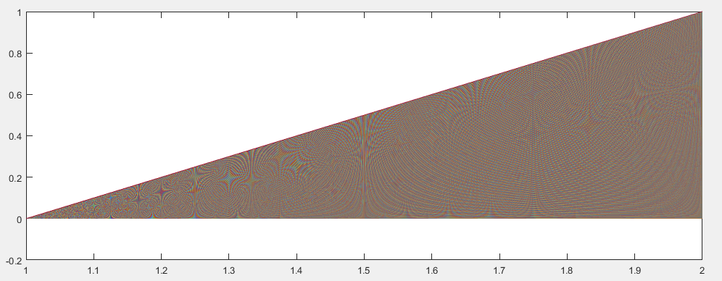

1. In VisualDSP++ 4.5, open a file named mydata for editing. Generate random integers and save them in the file. Reload the data in the same program and display and plot them.

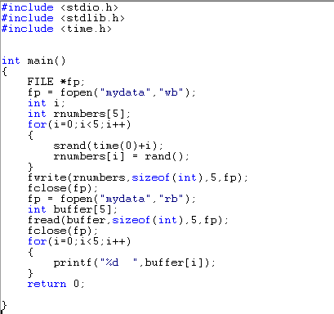



1. Save sinusoids of frequency 20Hz and 30Hz in an *.mat file. Retrieve the 20Hz sinusoidal only from the file.

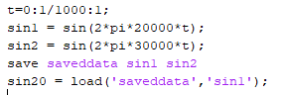

1. Generate an array of short in VisualDSP++ 4.5. Display the data in MATLAB.

**Visual DSP++:**

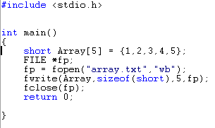

**Matlab:**



1. Import an integer array from MATLAB into VisualDSP++ 4.5 and perform its plotting.

MATLAB:

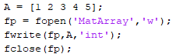

Visual DSP++:

